**EXPERIMENT 4**

Q1- Create a web page that has a frame to display w3schools.com.

Input:-

<!DOCTYPE html>

<html>

<head>

<title>iframe</title>

</head>

<frameset>

<frame src="https://www.w3schools.com"></frame>

</frameset>

<body></body>

</html>

Output:-

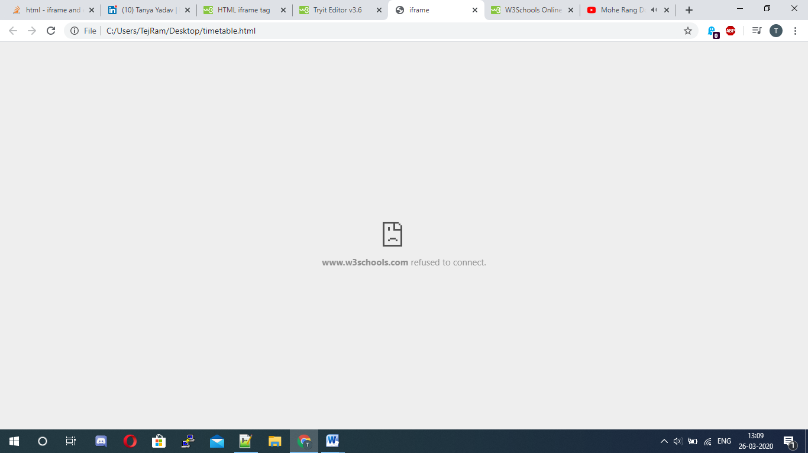

Q2- Create a web page that has a link google.com and it opens in a frame.

Input:-

<!DOCTYPE html>

<html>

<head>

<title>Link to frame</title>

</head>

<body>

<center> <a href="timetable.html">Click here</a></center>

</body>

</html>

Output:-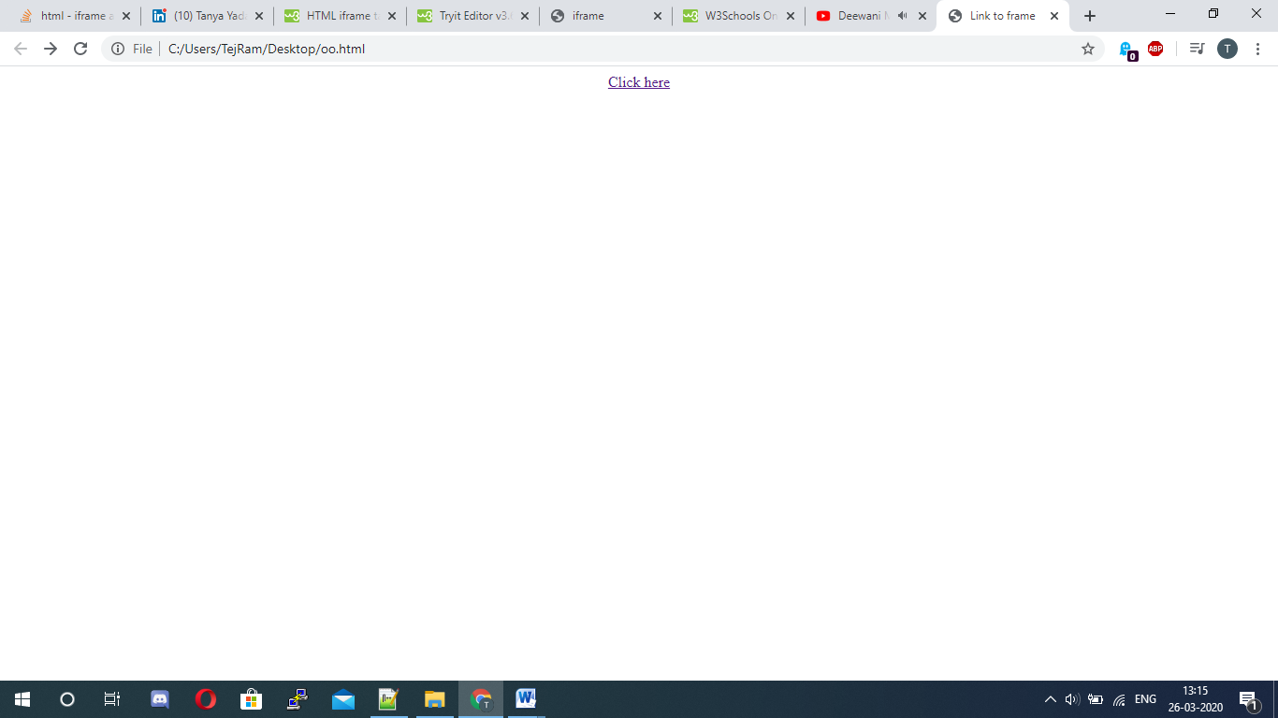Q3- Write a HTML code to generate following output:-

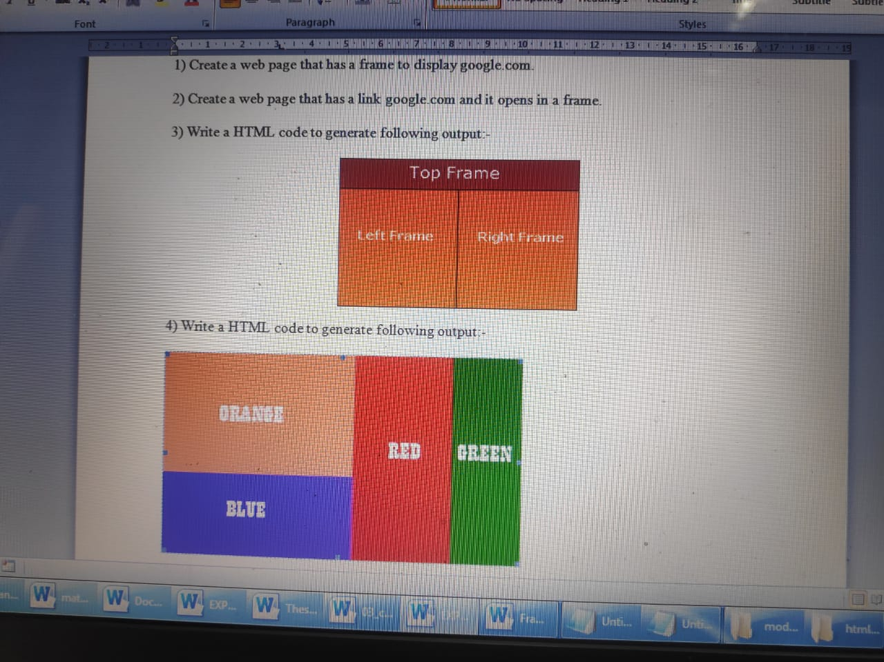

Input:-

<!Doctype html>

<html>

<head>

<title>3 Frame</title>

</head>

<frameset rows="25%,75%">

<frame src="file:///C:/Users/TejRam/Desktop/oo.html"

</frame>

<frameset cols="50%,50%">

<frame src="file:///C:/Users/TejRam/Desktop/timetable.html"></frame>

<frame src="file:///C:/Users/TejRam/Desktop/3.html"></frame>

</frameset>

</frameset>

<body></body>

</html>

Output:-

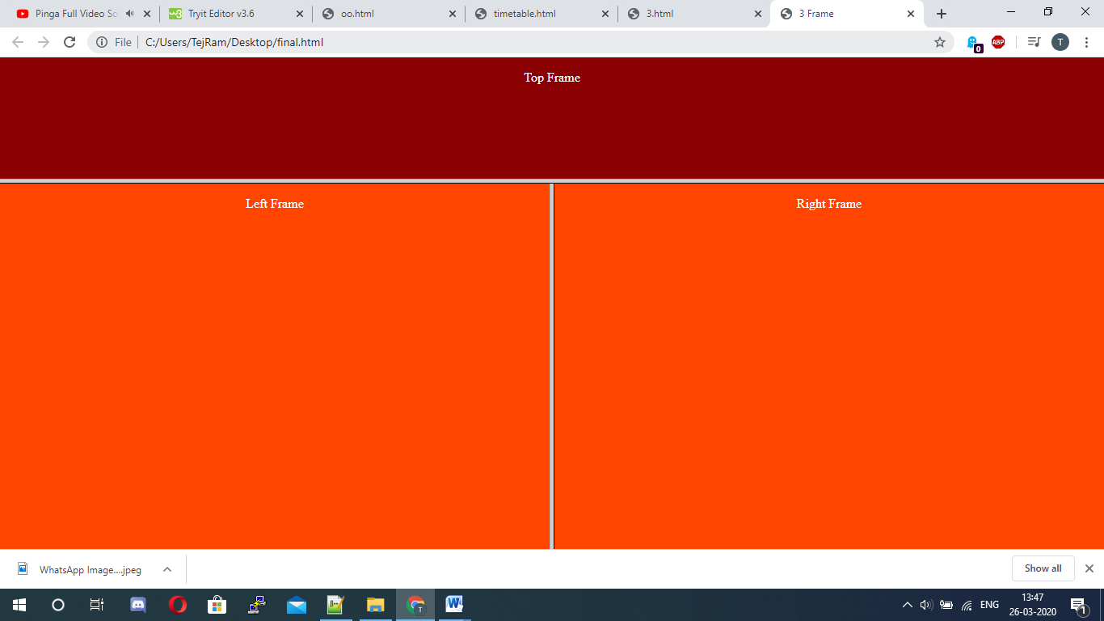

Q4- Write a HTML code to generate following output:-



Input:-

|  |
| --- |
| <!Doctype html> |
| <html> |
| <head> |
| <title>color frames</title> |
| </head> |
| <frameset cols="50%,50%"> |
| <frameset rows="50%,50%"> |
| <frame src="<file:///C:/Users/TOSHIBA/Desktop/1.html>"></frame> |
| <frame src="<file:///C:/Users/TOSHIBA/Desktop/2.html>"></frame> |
| </frameset> |
| <frameset cols="50%,50%"> |
| <frame src="<file:///C:/Users/TOSHIBA/Desktop/3.html>"></frame> |
| <frame src="<file:///C:/Users/TOSHIBA/Desktop/4.html>"></frame> |
| </frameset> |
| </frameset> |
| <body></body> |
| </html>  Output:-    Q5- Write a HTML code to generate following output:-  C:\Users\TejRam\Downloads\WhatsApp Image 2020-03-26 at 12.35.47 PM (1).jpeg  Input:-  <!Doctype html>  <html>  <head>  </head>  <frameset rows="20%,40%,40%">  <frame src="p4.5.1.html">  <frameset cols="50%,50%">  <frame src="p4.5.2.html">  <frame src="p4.5.3.html">  </frameset>  <frameset cols="33%,33%,33%">  <frame src="p4.5.4.html">  <frame src="p4.5.5.html">  <frame src="p4.5.6.html">  </frameset>  Output:- |

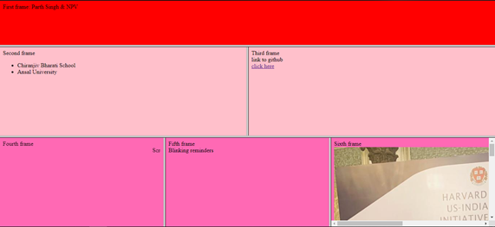

Q6- Create a HTML page consisting of two vertical frames. The left should contain a link, which open a page in right frame. This page should contain the text within some specific area. To see the overflow contents scroll bars should appear at bottom and right of block.

Input:-

<!Doctype html>

<html>

<head></head>

<frameset cols="50%,50%">

<frame src="ver0.html"> <frame name="ver2">

</html>

Output:-

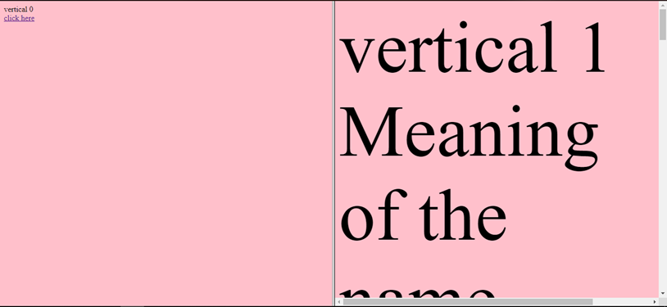

Q7- Create a HTML page consisting of a grid of 4 fixed frames. Put an image, a table, a list, and a paragraph respectively in these 4 frames.

Input:-

<!Doctype html>

<html>

<head>

</head>

<frameset rows="50%,50%">

<frameset cols="50%,50%">

<frame src="sixth.html"></frame> <frame src="table.html"></frame> </frameset>

<frameset cols="50%,50%">

<frame src="second.html"></frame> <frame src="para.html"></frame> </frameset>

</frameset>

</html>

Output:-

